Ex. No. : 03 Date: 23-02-2026
Register No.: 231701023 Name: S.V.Jashwanth

Wireframing and Prototyping Using Figma
Aim
To design a user-friendly mobile UI prototype for a stock prediction application (StockVision) using Figma, which visually represents stock predictions, dashboard insights, watchlist, and settings.
Procedure:
- Open Figma and create a new design file.
- Select a mobile frame (iPhone/Android size).
- Design the Home screen with app title, top pick card, and stock list.
- Create Prediction screens (Day, Week, Month) with stock data cards.
- Design Dashboard screen with charts and performance details.
- Create Watchlist screen to display saved stocks.
- Design Settings screen with options like Dark Mode and About.
- Add a bottom navigation bar for easy screen switching.
- Apply colors, fonts, spacing, and alignment for better UI.
- Use Figma prototype feature to link screens and simulate navigation.

Output
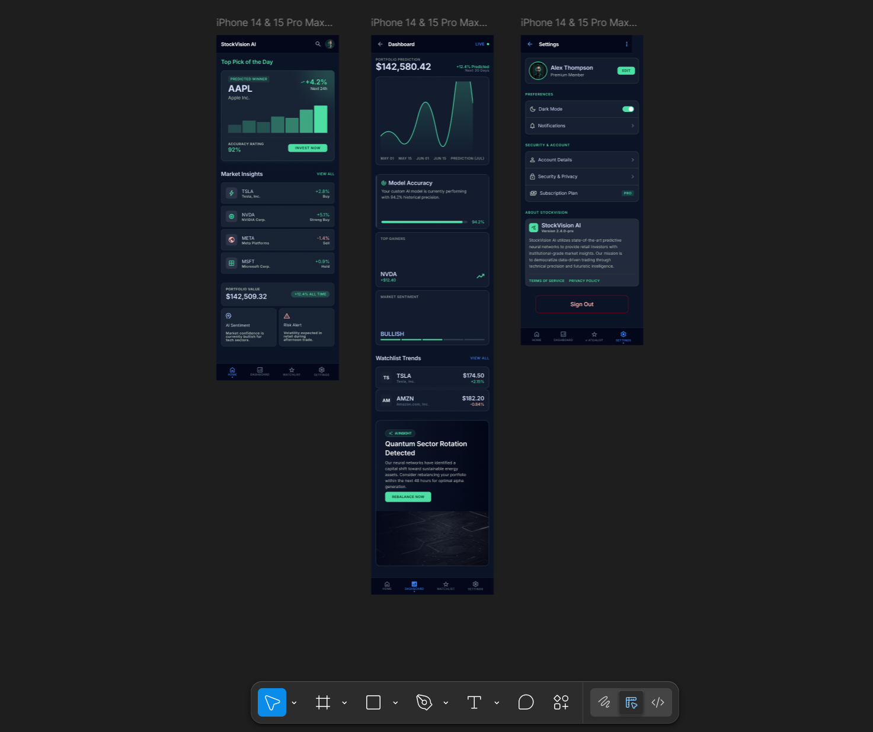

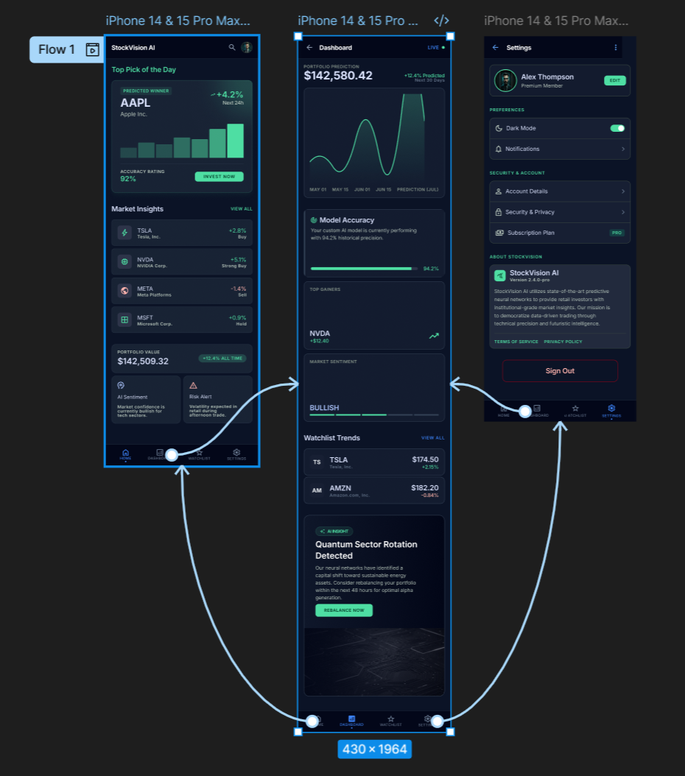

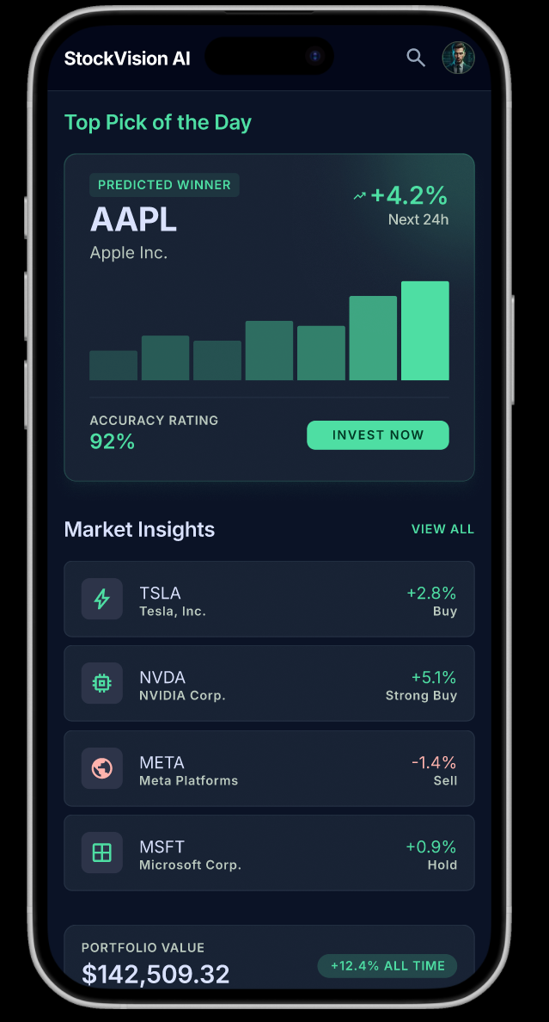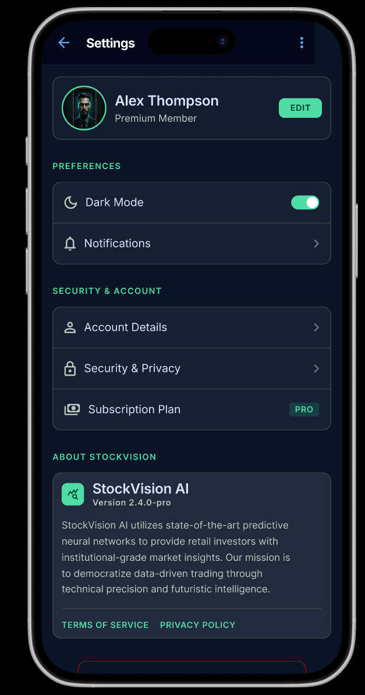

Result:
A clean and interactive UI prototype for the StockVision app was created using Figma, showing stock predictions and smooth navigation between screens.

